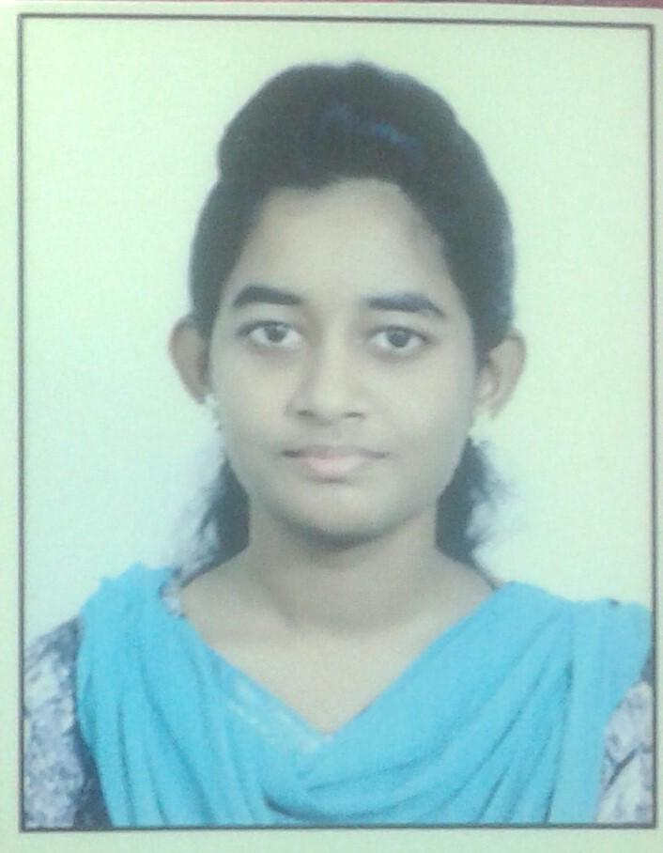**ANGEL.F**

413, Bharathiyar Street ,Swamy Ramalinga Colony

D-Block,Ponniammanmedu, Chennai-600110

9884845262

angelfrancis1111@gmail.com

Portfolio - <https://developedbyangel.github.io/Myportfolio/>

**Career Objective** Ambitious and self-motivated individual,seeks a challenging position in a reputable organization to expand my learning, knowledge and interpersonal skills

**Academic Background** 1) Name of the course :B.E in Computer Science

Year of Passing : April,2022

Institution .:Panimalar Engineering College

% of Marks : 9.02(CGPA)

2) Name of the course :12th /State Board

Year of Passing : May,2018

Institution . :St.Joseph Anglo-Indian Higher Secondary School

% of Marks : 89%

3) Name of the course :10th /State Board Year of Passing : May, 2016

Institution .:St.Joseph Anglo-Indian Higher Secondary School

% of Marks . : 93%

**Workshops Attended**  1) Attended a workshop on Artificial

Intelligence by Technobytes at IIT Madras

2)Attended a workshop on Android App development by Technobytes at IIT madras

**Industrial training** 1)Undertaken 5 days Internship by infoziant on IOT at Panimalar Engineering College from 25nd June to 30th June 2019

2)General Executive of club inquistives at studymonk(June 2020 - Present)

**Project Details**  **Mini Project** :”IOT automated Smart

Irrigation System”

**Project Area**: IOT

**Description** : An Irrigation System Automated through sensors and controllable through mobile.Powered by solar panel

**Certifications**  1)Completed a 4 week frontend developer bootcamp from studymonk Certificate Id:fe08a47a

2)Six week online training on Data Science at internshala from 6th April to 18th May, 2020 CertificateNo:52EAEC6F-EF09-2C94-6114-389 D0E01E611

3) Sololearn certification: https://www.sololearn.com/Profile/17910773

4) Skillrack certification: http://intern.skillrack.com/profile/262156/21

d95ded4886986b846852806d8d680484c3fd 44

**Awards and achievements** 1) Presented a poster titled ‘Vehicle detection and

warning’ at the Science Bazaar by WHD

2) Presented a poster titled ‘Converting speech to Braille’ at the Science Bazaar by WHD

**Personal details**  Name - Angel.F

Date of birth - 18/06/2001

Gender - Female

Nationality - Indian

Languages - English, Tamil